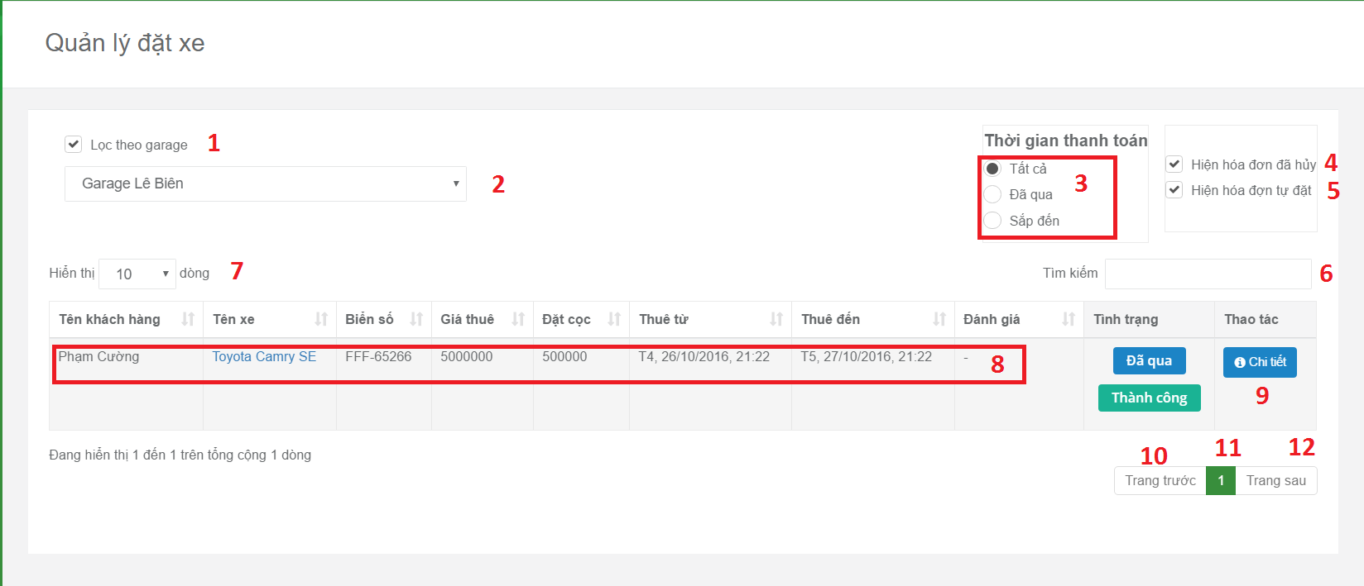

**Fields:**

|  |  |  |  |  |  |  |
| --- | --- | --- | --- | --- | --- | --- |
| No | Field Name | Description | Read Only | Mandatory | Control Type | Data Type |
| 2 | Garage name | Filter vehicle belong to garage | Yes | No | Dropdown | String |
| 1 | Disable/enable filter record belong to garage | Filter vehicle belong to garage be disabled/enabled | Yes | No | Checkbox | String |
| 7 | Number record in data table | Filter number record be showed in data table | Yes | No | Dropdown | Number |
| 6 | Key search | Filter record belong to key word | No | No | Textbox | String |
| 3 | Status of booking sorted by time | Filter record of booking be showed in data table belong to status of booking | Yes | No | Radiobox | String |
| 4 | Status of booking sorted by action | Filter record of booking be showed in data table belong to status of sorted by action | Yes | No | Checkbox | String |
| 11 | Current Page Of Table | Current page of table | Yes | No | Text Box | String |

**Buttons/Hyperlinks:**

|  |  |  |  |  |
| --- | --- | --- | --- | --- |
| No | Function | Description | Validation | Outcome |
| 8 | Redirect to vehicle detail page | Show information of vehicle | N/A | Vehicle detail page. |
| 9 | Show booking in detail | Show pop up to show booking information | N/A | Show pop up to show booking information |
| 10 | Show Previous Record Of Table | Show previous record of table | N/A | Show previous record of table |
| 12 | Show Next Record Of Table | Show next record of table | N/A | Show next record of table |